**Bronson Mini Storage, LLC**

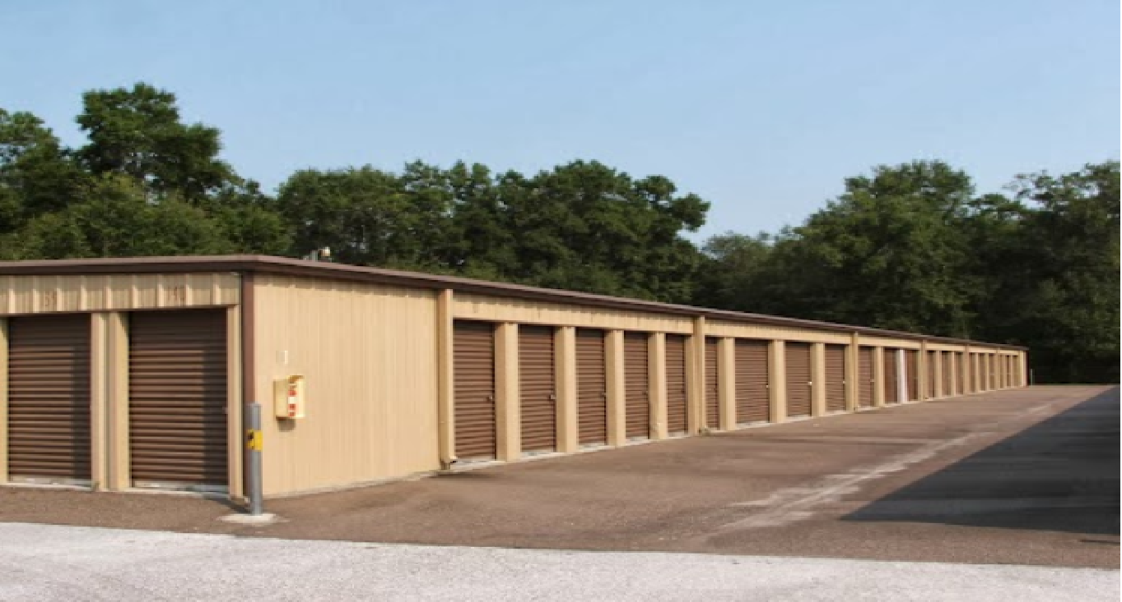

Submitted by:

Michael W. Wagner

March 3rd, 2018

Table of Contents

**I. Executive Summary**

**A. Company Information 3**

**B. Company Objective 3**

**C. Company Summary 3**

**D. Loan Request Summary 4**

**II. Area Description 5**

**III. Market Position 6**

**IV. Property Description 7**

**V. Competition 8**

**VI. Planned Improvements 8**

**VII. Management 9**

**VIII. Marketing 10**

**IX. Source and Use of Funds 11**

**X. Income/Expense Detail 11**

**XI. Investor Returns 11**

**XII. Principal’s Background 15**

**XIII. Project Timeline 18**

**Appendix A – Operating Agreements To Be Appended**

**I.** **Executive Summary**

**A. Company Information**

Bronson Self Storage, LLC will be filed with the New York State Department of Corporations in April of 2018. The first operational meeting was held on November 14th, 2017 at which time the operating agreement (Appendix A) was adopted. Bronson Self Storage, LLC will be owned by Michael W. Wagner, Managing Member as well as by one silent minority (19%) partner. It will be managed solely by Michael W. Wagner, Managing Member. The principle office of Bronson Self Storage, LLC is located at 500 Commerce Street, Bronson Fl 32621. The legal mailing address is Bronson Self Storage, LLC is _____________________.

**B. Company Objective**

The primary objective of Bronson Self Storage, LLC is to purchase an under performing self storage asset and complete a full operational overhaul to optimize performance and value. Doing so will allow the principals, investors and any subsequent owners to profitably provide quality, secured storage options to private individuals and businesses in and around Bronson, FL.

**C. Company Summary**

Immediately upon acquisition, the managing member of Bronson Self Storage, LLC will initiate and complete a full operational overhaul, detailed herein, enabling the company to provide quality, secured storage options to individuals and businesses in and around Bronson, FL.

**Project Summary**

**Project: Bronson Self Storage, LLC**

**Description:** Bronson Self Storage, LLCwill purchase an existing 24,000 square foot self storage facility. Said facility was built in 2000 (later purchased in 2003 by the current owner for $860,000) and was well run for more than a decade. Within the last three years, the owner's advancing age forced her to delegate management to her son who lives in North Carolina. Since that time, occupancy has dwindled to 47% and foreclosure is imminent.

**Principals:** Michael W. Wagner, Managing Member

[mikew@mwwagner.com](mailto:mikew@mwwagner.com)

315-403-4696

**Purpose of Investment:**

To provide down payment toward full cost of acquisition.

Purchase Price: $465,000

Repairs: $15,000

Transactional Costs : $20,000

**Total Funds Required:** $500,000

Source of Funds:

1st Mortgage $384,000

Investor/Partner $95,000

Prinicpal $21,000

**Terms:**  Seeking $385,000 at 5.5% for 20 years with no pre-payment penalty

**Security Offered:** First Position Mortgage as well as assignment of leases/rents.

.

**II. Area Description**

**Bronson Florida; Levy County**

- 2,967 residents within 3 mile radius

- 6,855 residents within 5 mile radius

* + - * Population in Bronson, FL has increased by 26.8% since 2000
      * 2,070 multi-family or mobile home housing units within 3 mile radius

- Average Household Income within 1 mile: $33,431

- Average Household Income within 2 mile: $33,862

- Average Household Income within 5 mile: $35,757

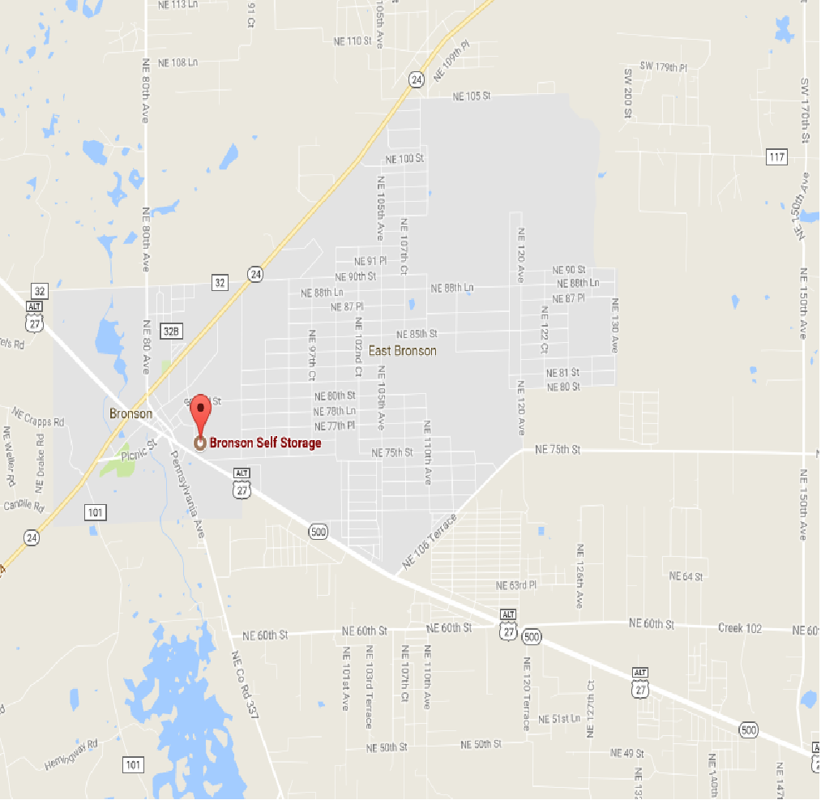

**III. Market Position**

**Bronson Self Storage**

* Only storage facility in town.
* Nearest Competitor is over 12.3 miles away.
* Daily Traffic Count of 8,600 cars at driveway
* Strategically located in the Town Center in close proximity to the Town's two supermarkets, adjacent to the Dollar General and across the street from a Subway Franchise
* Forecasted demand for Storage is approx. 7 square feet per person
* Current total supply of storage within 5 Mile radius is 3.5 square feet per person

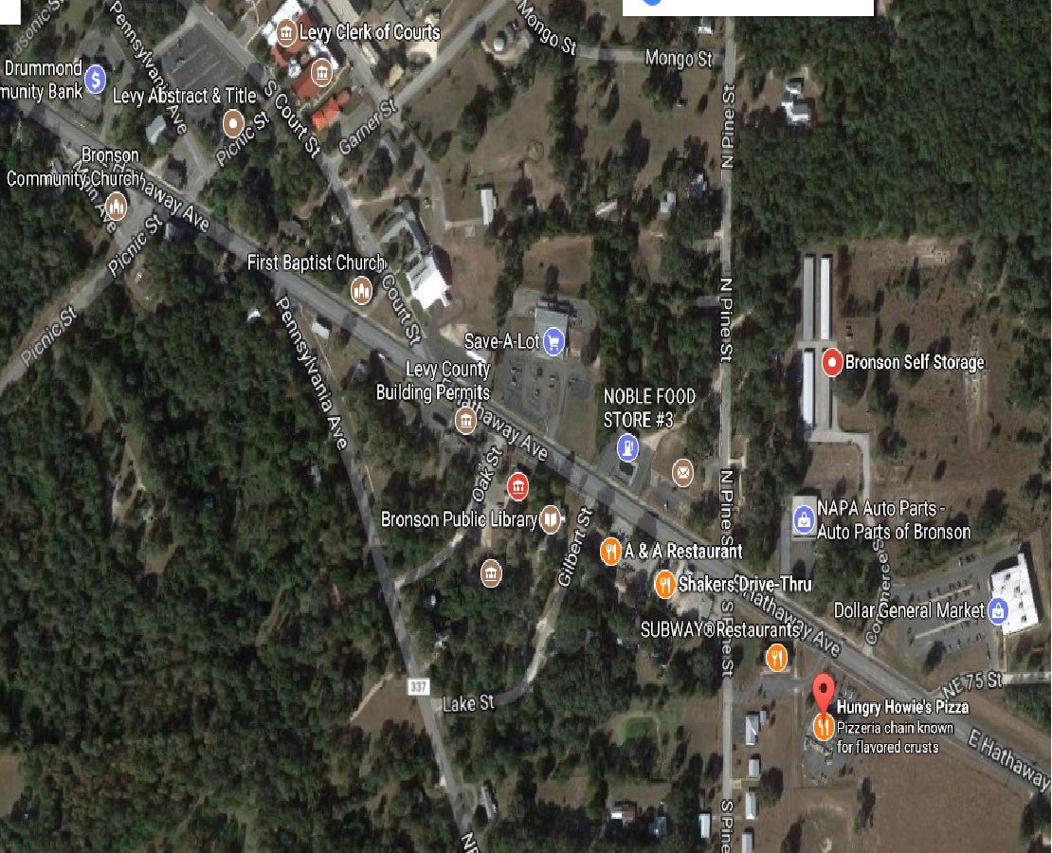

**IV. Property Description**

Bronson Self Storage is a four building, 193 unit facility totaling approximately 24,000 square feet of rentable indoor storage space on 3.68 acres of land along Route 27 in Bronson, Florida. The facility is fully enclosed by perimeter fencing and has an electronic security gate with keypad access. Each of the four traditional self-storage buildings sit atop a poured concrete foundation and are constructed of highly durable steel with metal rolling doors. The buildings are in overall good condition with no signs of excessive neglect.

**Photos**

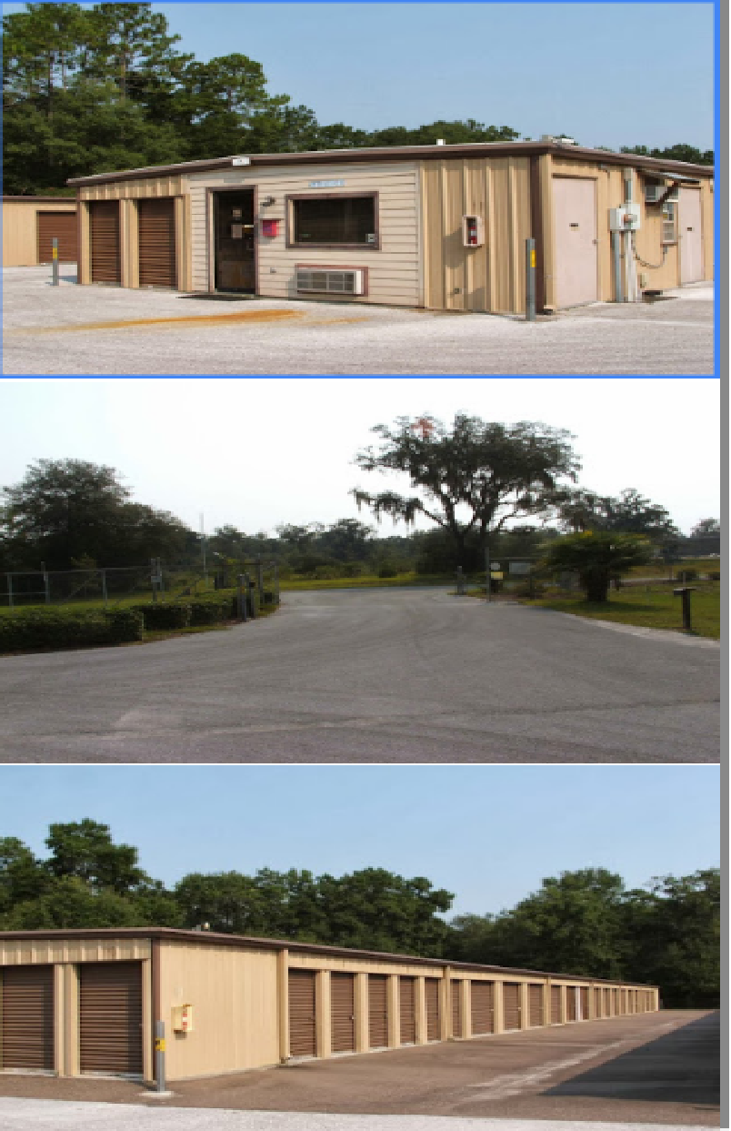

1. **Competition**

Competition within this market is essentially non-existent. The nearest facilities are more than 12 miles away and as such, do not represent direct competition to this location. Generally speaking, storage customers will not drive more than 5-7 miles for storage. Additionally, studies show that storage customers are highly averse, to driving past one facility in favor of another one. That being said, the rates charged and amenities offered by competitors in neighboring small towns do offer insight into unit pricing and amenities desired by the customers in these markets. The amenities offered by the subject property are similar to those offered by the three other storage facilities included below. The rental rates are also in line with the average price charged in the neighboring towns.

|  |  |  |  |  |  |  |  |
| --- | --- | --- | --- | --- | --- | --- | --- |
|  | **Bronson Self Storage** | **Store It Storage** | **Newberry Mini Storage** | **Whittle's Mini Storage** | | | |
|  | Subject | 12.8 Miles | 14.55 Miles | 15.0 Miles | | | |
| **Unit Size** |  |  |  |  | |  | |
| 5' x 5' | - | - | 50 | - | |  | |
| 5' x 10' | 42 | 38 | 60 | 60 | |  | |
| 10' x 10' | 66 | 56 | 88 | 75 | |  | |
| 10' x 15' | 82 | 69 | - | 90 | |  | |
| 10' x 20' | 104 | 95 | - | 105 | |  | |
| 10' x 25' | - | - | 160 | - | |  | |
| 10' x 30' | 135 | 119 | - | - | |  | |
|  |  |  |  |  |  | |  |
| Total Sq. Ft. | 23400 | 23700 | 10800 | 12200 |  | |  |
| Occupancy | 47.00% |  |  |  |  | |  |

**VI. Planned Improvements**

Improvements needed at site are managerial in nature and will be detailed in the following section. No major physical improvements are required at the facility at this time. There is ample land available on this parcel to add 12,000-24,000 square feet of storage as dictated by demand.

Income and expense projections can be found in the table in Section X below (or attached xls file). Note that all income projections are based on the conservative assumption that the proposed operational overhaul will yield 2 net move ins per month at an average value of $75 per move in. As such, it is projected that income will increase by only $150 per month until achieving stable occupancy at 87%. Even with this very conservative projection in revenue growth, the overall performance of this asset and the resultant increase in equity are impressive and provide great security for the lender.

**VII. Management**

The managing partner will deploy the same successful management strategies that have enabled him to successfully overhaul and re-develop 65,000 square feet of storage in the last 6 years. New on-site management will deliver high level customer service and prompt, integrity-based attention to customer needs during consistent and reliable office hours. After hours appointments will also be used regularly to better meet the needs of our customers. Additionally, the management software that we employ will allow customers to rent and pay for units online without ever having to deal with a office manager on site if that is their preference. We will also utilize a call center to ensure that customers can reach a live customer service representative from 9 am to 8 pm Monday through Friday and from 11 am to 4 pm on Saturday. These representatives are in house employees of the company that provides our management software and, as such, have the skills and infrastructure to fully service our customers with move ins, move outs, payments and account management.

On-site management will strictly adhere to company policies which require aggressive and legal collection procedures, systematic and expedient lien law enforcement as well as regular auctions. Additionally, management will work to keep expenses at or below industry norms.

The anticipated dramatic improvement in occupancy and profitability will be a direct result of an improved management structure, strict collection procedures, improved facility signage, targeted marketing efforts and an emphasis on high level customer service.

**VIII. Marketing**

## Long-term success in the self storage industry requires frequent and creative marketing campaigns encompassing traditional, online and grassroots marketing. The following is an outline of the strategy that will used. It will also serve as a guide for further refinement in order to maximize marketing efficiency.

## Because a large percentage of mini storage customers come from “drive by traffic”, both permanent and temporary roadside signage will be used to the full extent permitted by Town codes.

## Upon opening, direct hard copy marketing efforts such as flyers, pamphlets and circular advertisement will be used to announce new ownership and management. Additionally, a dominant web presence will be established via the creation of an easily optimized website, www.BronsonSelfStorage.com. As mentioned above, the professionally designed site will also serve as an avenue by which customers can rent and pay for storage spaces. Specific online marketing strategies include maintaining active listings with self-storage directories/aggregator sites, web-based Yellow Page Listings, organic and paid search engine optimization (SEO), Google pay per click promotions and the use of social media outlets such Facebook.

Management will also launch a customer friendly automatic debit payment system. Said system will help to simplify the lives of our customers while, at the same time, improving customer retention. Studies indicate that patrons who use auto-pay retain storage services for 40% longer than those who are required to write monthly checks. Alternative electronic payment methods will also be available to maximize convenience for customers.

An aggressive referral program will be initiated to encourage clients to share our services with their friends and family. Specifically, current tenants (as well as those they refer) receive a $25 credit for every customer that they refer to the facility. Management also has experience in establishing a robust Strategic Alliance Program in which affiliates are provided with custom marketing materials to distribute to their clients. Affiliates are incentivized with a $25 payment for every referral. Program participants will include real estate professionals, apartment complex managers, movers, RV dealerships, and Marinas.

Management also embraces grassroots marketing, reaching out to the community to donate money and/or space to worthy organizations. Bronson Self Storage, LLC will be an active member in the local chamber of commerce. Additionally, the principal will work closely with the American Red Cross, Toys for Tots, Planet Aide and/or other worthy organizations to increase exposure while giving back to the communities that we serve.

Generally speaking, Bronson Self Storage will trend toward a pay for performance marketing model in which the cost of our marketing efforts are largely tied to the success of each medium used.

**IX. Source and Use of Funds:**

Purchase Price: $465,000

Repairs $15,000

Transactional Costs: $20,000

**Total Investment: $500,000**

1st Mortgage: $384,000

Investor/Partner: $95,000

Principal Contribution $21,000

**X. Income/Expense Detail and Projected Investor Returns**

See top of the next page (if this is a hard copy) or attached xls file named Bronson SS

(if this is a digital copy) for full financial analysis.

**XI. Investor Returns**

$95,000 Investment will be in exchange for 19% of the quarterly cash flow as well 19% equity stake in the property. While I fully expect to meet or exceed these projections it should be noted that they are not guaranteed and actual returns may be more or less.

The investment will be subordinated to the first mortgage and will therefore be additionally secured by a $100,000 Life Insurance Policy with the Investor listed as sole beneficiary.

Investment will be further secured by an ironclad partnership agreement that spells out all roles and responsibilities of each partner as well the terms of the agreement presented very generally below:

**XII.** **Principal’s** **Background**

I have been an active real estate investor since February of 2007. Between 2007 and 2011, I acquired 31 apartments while working full-time as a Physical Therapist. In 2011, I quit my job the day before closing on my first struggling self-storage facility. This facility was less than 50% full and losing roughly $2,000 per month with the debt service I had in place to purchase it. Within 9 months, the facility was 97% full and after three rounds of expansion is now valued at $2,100,000. Similarly, the second facility, bought in 2014 for $360,000 was 55% occupied and just about break even when I bought it. It is now valued at close to $900,000 and is projected to be worth $1,100,000 as a result of three rounds of expansion (the third of which was just completed last month. While the results presented in the tables below (or in the attached file named Storage Project Performance.xls if this is a digital copy) cannot guarantee future performance, they do I believe show that my projections for this project are in line with past experience. They also convey my qualifications in this sector specifically as they relate to turning around underperforming storage facilities.

**XIV. Project Timeline**

January 26tht Contract for Purchase Fully Executed

February 3rd Attorney Approval of Contract

February 15th Property Inspection

April 16th Closing

April 17th Initiate Operational Overhaul as detailed herein with

priority placed on immediately contacting all existing

customers to notify of new ownership, implement new

management software and call center